Graph
A graph can be defined as group of vertices and edges that are used to connect these vertices. A graph can be seen as a cyclic tree, where the vertices (Nodes) maintain any complex relationship among them instead of having parent child relationship.

Definition
A graph G can be defined as an ordered set G(V, E) where V(G) represents the set of vertices and E(G) represents the set of edges which are used to connect these vertices.
A Graph G(V, E) with 5 vertices (A, B, C, D, E) and six edges ((A,B), (B,C), (C,E), (E,D), (D,B), (D,A)) is shown in the following figure.
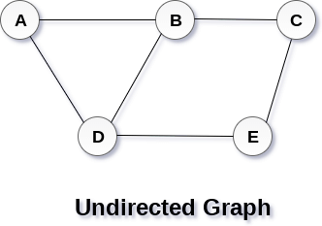

Directed and Undirected Graph
A graph can be directed or undirected. However, in an undirected graph, edges are not associated with the directions with them. An undirected graph is shown in the above figure since its edges are not attached with any of the directions. If an edge exists between vertex A and B then the vertices can be traversed from B to A as well as A to B.
In a directed graph, edges form an ordered pair. Edges represent a specific path from some vertex A to another vertex B. Node A is called initial node while node B is called terminal node.
A directed graph is shown in the following figure.
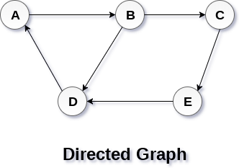

Graph Terminology

Path
A path can be defined as the sequence of nodes that are followed in order to reach some terminal node V from the initial node U.

Closed Path
A path will be called as closed path if the initial node is same as terminal node. A path will be closed path if V₀=V_{N}.

Simple Path
If all the nodes of the graph are distinct with an exception V₀=V_{N}, then such path P is called as closed simple path.

Cycle
A cycle can be defined as the path which has no repeated edges or vertices except the first and last vertices.

Connected Graph
A connected graph is the one in which some path exists between every two vertices (u, v) in V. There are no isolated nodes in connected graph.

Complete Graph
A complete graph is the one in which every node is connected with all other nodes. A complete graph contain n(n-1)/2 edges where n is the number of nodes in the graph.

Weighted Graph
In a weighted graph, each edge is assigned with some data such as length or weight. The weight of an edge e can be given as w(e) which must be a positive (+) value indicating the cost of traversing the edge.

Digraph
A digraph is a directed graph in which each edge of the graph is associated with some direction and the traversing can be done only in the specified direction.

Loop
An edge that is associated with the similar end points can be called as Loop.

Adjacent Nodes
If two nodes u and v are connected via an edge e, then the nodes u and v are called as neighbours or adjacent nodes.

Degree of the Node
A degree of a node is the number of edges that are connected with that node. A node with degree 0 is called as isolated node.

Difference Between Graph and Tree
Feature | Graph | Tree
Definition | A collection of nodes (vertices) and edges, where edges connect nodes. | A hierarchical data structure consisting of nodes connected by edges with a single root node.
Structure | Can have cycles (loops) and disconnected components. | No cycles; connected structure with exactly one path between any two nodes.
Root Node | No root node; nodes may have multiple parents or no parents at all. | Has a designated root node that has no parent.
Node Relationship | Relationships between nodes are arbitrary. | Parent-child relationship; each node (except the root) has exactly one parent.
Edges | Each node can have any number of edges. | If there is n nodes then there would be n-1 number of edges
Traversal Complexity | Traversal can be complex due to cycles and disconnected components. | Traversal is straightforward and can be done in linear time.
Application | Used in various scenarios like social networks, maps, network optimization, etc. | Commonly used for hierarchical data representation like file systems, organization charts, HTML DOM, XML documents, etc.
Examples | Social networks, road networks, computer networks. | File systems, family trees, HTML DOM structure.

Graph representation
In this article, we will discuss the ways to represent the graph. By Graph representation, we simply mean the technique to be used to store some graph into the computer's memory.
A graph is a data structure that consist a sets of vertices (called nodes) and edges. There are two ways to store Graphs into the computer's memory:
- Sequential representation (or, Adjacency matrix representation)
- Linked list representation (or, Adjacency list representation)
In sequential representation, an adjacency matrix is used to store the graph. Whereas in linked list representation, there is a use of an adjacency list to store the graph.

Sequential representation
In sequential representation, there is a use of an adjacency matrix to represent the mapping between vertices and edges of the graph. We can use an adjacency matrix to represent the undirected graph, directed graph, weighted directed graph, and weighted undirected graph.
If adj[i][j] = w, it means that there is an edge exists from vertex i to vertex j with weight w.
An entry A_{ij} in the adjacency matrix representation of an undirected graph G will be 1 if an edge exists between V_{i} and V_{j}. If an Undirected Graph G consists of n vertices, then the adjacency matrix for that graph is n x n, and the matrix A = [aij] can be defined as -
a_{ij} = 1 {if there is a path exists from V_{i} to V_{j}}
a_{ij} = 0 {Otherwise}
It means that, in an adjacency matrix, 0 represents that there is no association exists between the nodes, whereas 1 represents the existence of a path between two edges.
If there is no self-loop present in the graph, it means that the diagonal entries of the adjacency matrix will be 0.
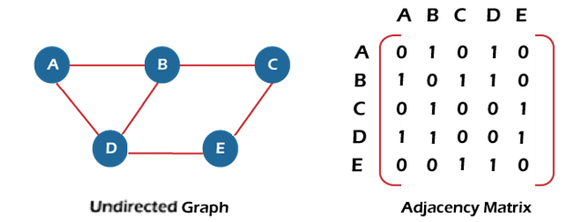
In the above figure, an image shows the mapping among the vertices (A, B, C, D, E), and this mapping is represented by using the adjacency matrix.
There exist different adjacency matrices for the directed and undirected graph. In a directed graph, an entry A_{ij} will be 1 only when there is an edge directed from V_{i} to V_{j}.

Adjacency matrix for a directed graph
In a directed graph, edges represent a specific path from one vertex to another vertex. Suppose a path exists from vertex A to another vertex B; it means that node A is the initial node, while node B is the terminal node.
Consider the below-directed graph and try to construct the adjacency matrix of it.
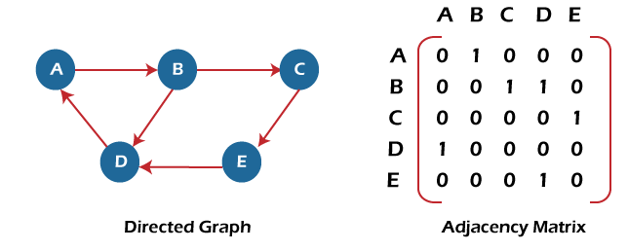
In the above graph, we can see there is no self-loop, so the diagonal entries of the adjacent matrix are 0.
Adjacency matrix for a weighted directed graph
It is similar to an adjacency matrix representation of a directed graph except that instead of using the '1' for the existence of a path, here we have to use the weight associated with the edge. The weights on the graph edges will be represented as the entries of the adjacency matrix. We can understand it with the help of an example. Consider the below graph and its adjacency matrix representation. In the representation, we can see that the weight associated with the edges is represented as the entries in the adjacency matrix.
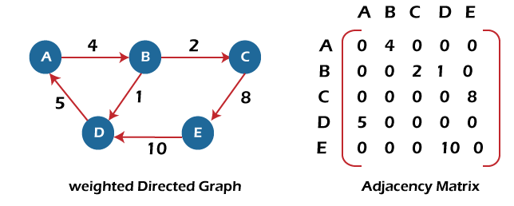
In the above image, we can see that the adjacency matrix representation of the weighted directed graph is different from other representations. It is because, in this representation, the non-zero values are replaced by the actual weight assigned to the edges.
Adjacency matrix is easier to implement and follow. An adjacency matrix can be used when the graph is dense and a number of edges are large.
Though, it is advantageous to use an adjacency matrix, but it consumes more space. Even if the graph is sparse, the matrix still consumes the same space.

Linked list representation
An adjacency list is used in the linked representation to store the Graph in the computer's memory. It is efficient in terms of storage as we only have to store the values for edges.
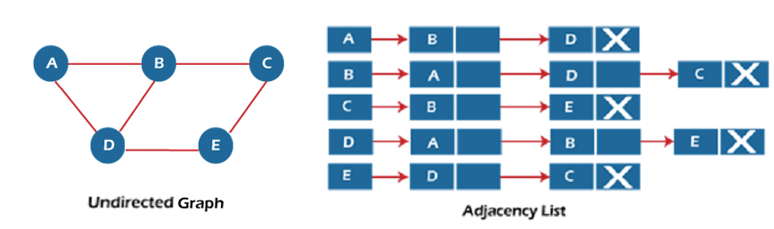
In the above figure, we can see that there is a linked list or adjacency list for every node of the graph. From vertex A, there are paths to vertex B and vertex D. These nodes are linked to nodes A in the given adjacency list.
An adjacency list is maintained for each node present in the graph, which stores the node value and a pointer to the next adjacent node to the respective node. If all the adjacent nodes are traversed, then store the NULL in the pointer field of the last node of the list.
The sum of the lengths of adjacency lists is equal to twice the number of edges present in an undirected graph.
Now, consider the directed graph, and let's see the adjacency list representation of that graph.
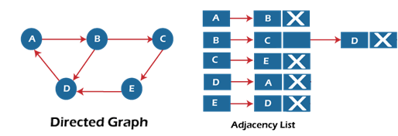
For a directed graph, the sum of the lengths of adjacency lists is equal to the number of edges present in the graph.
Now, consider the weighted directed graph, and let's see the adjacency list representation of that graph.
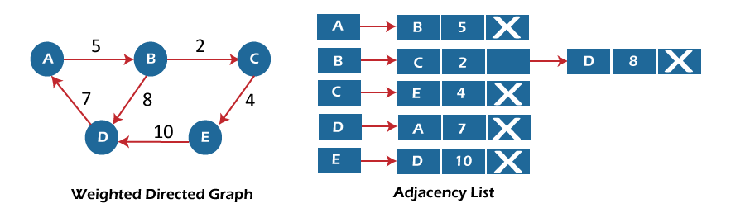
In the case of a weighted directed graph, each node contains an extra field that is called the weight of the node.
In an adjacency list, it is easy to add a vertex. Because of using the linked list, it also saves space.

Implementation of adjacency matrix representation of Graph
Now, let's see the implementation of adjacency matrix representation of graph in C.
In this program, there is an adjacency matrix representation of an undirected graph. It means that if there is an edge exists from vertex A to vertex B, there will also an edge exists from vertex B to vertex A.
Here, there are four vertices and five edges in the graph that are non-directed.
- /* Adjacency Matrix representation of an undirected graph in C */

- #include <stdio.h>
- #define V 4 /* number of vertices in the graph */

- /* function to initialize the matrix to zero */
- void init(int arr[][V]) {
- int i, j;
- for (i = 0; i < V; i++)
- for (j = 0; j < V; j++)
- arr[i][j] = 0;
- }

- /* function to add edges to the graph */
- void insertEdge(int arr[][V], int i, int j) {
- arr[i][j] = 1;
- arr[j][i] = 1;
- }

- /* function to print the matrix elements */
- void printAdjMatrix(int arr[][V]) {
- int i, j;
- for (i = 0; i < V; i++) {
- printf("%d: ", i);
- for (j = 0; j < V; j++) {
- printf("%d ", arr[i][j]);
- }
- printf("\n");
- }
- }

- int main() {
- int adjMatrix[V][V];

- init(adjMatrix);
- insertEdge(adjMatrix, 0, 1);
- insertEdge(adjMatrix, 0, 2);
- insertEdge(adjMatrix, 1, 2);
- insertEdge(adjMatrix, 2, 0);
- insertEdge(adjMatrix, 2, 3);

- printAdjMatrix(adjMatrix);

- return 0;
- }
Output:
After the execution of the above code, the output will be -
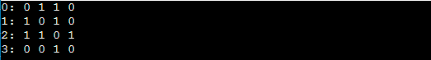

Implementation of adjacency list representation of Graph
Now, let's see the implementation of adjacency list representation of graph in C.
In this program, there is an adjacency list representation of an undirected graph. It means that if there is an edge exists from vertex A to vertex B, there will also an edge exists from vertex B to vertex A.
- /* Adjacency list representation of a graph in C */
- #include <stdio.h>
- #include <stdlib.h>

- /* structure to represent a node of adjacency list */
- struct AdjNode {
- int dest;
- struct AdjNode* next;
- };

- /* structure to represent an adjacency list */
- struct AdjList {
- struct AdjNode* head;
- };

- /* structure to represent the graph */
- struct Graph {
- int V; /*number of vertices in the graph*/
- struct AdjList* array;
- };

- struct AdjNode* newAdjNode(int dest)
- {
- struct AdjNode* newNode = (struct AdjNode*)malloc(sizeof(struct AdjNode));
- newNode->dest = dest;
- newNode->next = NULL;
- return newNode;
- }

- struct Graph* createGraph(int V)
- {
- struct Graph* graph = (struct Graph*)malloc(sizeof(struct Graph));
- graph->V = V;
- graph->array = (struct AdjList*)malloc(V * sizeof(struct AdjList));

- /* Initialize each adjacency list as empty by making head as NULL */
- int i;
- for (i = 0; i < V; ++i)
- graph->array[i].head = NULL;
- return graph;
- }

- /* function to add an edge to an undirected graph */
- void addEdge(struct Graph* graph, int src, int dest)
- {
- /* Add an edge from src to dest. The node is added at the beginning */
- struct AdjNode* check = NULL;
- struct AdjNode* newNode = newAdjNode(dest);

- if (graph->array[src].head == NULL) {
- newNode->next = graph->array[src].head;
- graph->array[src].head = newNode;
- }
- else {

- check = graph->array[src].head;
- while (check->next != NULL) {
- check = check->next;
- }
- // graph->array[src].head = newNode;
- check->next = newNode;
- }

- /* Since graph is undirected, add an edge from dest to src also */
- newNode = newAdjNode(src);
- if (graph->array[dest].head == NULL) {
- newNode->next = graph->array[dest].head;
- graph->array[dest].head = newNode;
- }
- else {
- check = graph->array[dest].head;
- while (check->next != NULL) {
- check = check->next;
- }
- check->next = newNode;
- }
- }
- /* function to print the adjacency list representation of graph*/
- void print(struct Graph* graph)
- {
- int v;
- for (v = 0; v < graph->V; ++v) {
- struct AdjNode* pCrawl = graph->array[v].head;
- printf("\n The Adjacency list of vertex %d is: \n head ", v);
- while (pCrawl) {
- printf("-> %d", pCrawl->dest);
- pCrawl = pCrawl->next;
- }
- printf("\n");
- }
- }

- int main()
- {

- int V = 4;
- struct Graph* g = createGraph(V);
- addEdge(g, 0, 1);
- addEdge(g, 0, 3);
- addEdge(g, 1, 2);
- addEdge(g, 1, 3);
- addEdge(g, 2, 4);
- addEdge(g, 2, 3);
- addEdge(g, 3, 4);
- print(g);
- return 0;
- }
Output:
In the output, we will see the adjacency list representation of all the vertices of the graph. After the execution of the above code, the output will be -
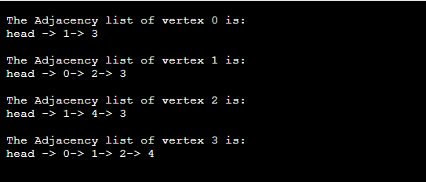

BFS algorithm
Breadth-first search is a graph traversal algorithm that starts traversing the graph from the root node and explores all the neighboring nodes. Then, it selects the nearest node and explores all the unexplored nodes. While using BFS for traversal, any node in the graph can be considered as the root node.
There are many ways to traverse the graph, but among them, BFS is the most commonly used approach. It is a recursive algorithm to search all the vertices of a tree or graph data structure. BFS puts every vertex of the graph into two categories - visited and non-visited. It selects a single node in a graph and, after that, visits all the nodes adjacent to the selected node.

Applications of BFS algorithm
The applications of breadth-first-algorithm are given as follows -
- BFS can be used to find the neighboring locations from a given source location.
- In a peer-to-peer network, BFS algorithm can be used as a traversal method to find all the neighboring nodes. Most torrent clients, such as BitTorrent, uTorrent, etc. employ this process to find "seeds" and "peers" in the network.
- BFS can be used in web crawlers to create web page indexes. It is one of the main algorithms that can be used to index web pages. It starts traversing from the source page and follows the links associated with the page. Here, every web page is considered as a node in the graph.
- BFS is used to determine the shortest path and minimum spanning tree.
- BFS is also used in Cheney's technique to duplicate the garbage collection.
- It can be used in ford-Fulkerson method to compute the maximum flow in a flow network.

Algorithm
The steps involved in the BFS algorithm to explore a graph are given as follows -
Step 1: SET STATUS = 1 (ready state) for each node in G
Step 2: Enqueue the starting node A and set its STATUS = 2 (waiting state)
Step 3: Repeat Steps 4 and 5 until QUEUE is empty
Step 4: Dequeue a node N. Process it and set its STATUS = 3 (processed state).
Step 5: Enqueue all the neighbours of N that are in the ready state (whose STATUS = 1) and set their STATUS = 2
(waiting state)
[END OF LOOP]
Step 6: EXIT

Example of BFS algorithm
Now, let's understand the working of BFS algorithm by using an example. In the example given below, there is a directed graph having 7 vertices.
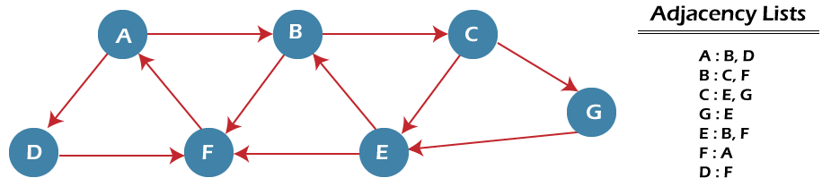
In the above graph, minimum path 'P' can be found by using the BFS that will start from Node A and end at Node E. The algorithm uses two queues, namely QUEUE1 and QUEUE2. QUEUE1 holds all the nodes that are to be processed, while QUEUE2 holds all the nodes that are processed and deleted from QUEUE1.
Now, let's start examining the graph starting from Node A.
Step 1 - First, add A to queue1 and NULL to queue2.
- QUEUE1 = {A}
- QUEUE2 = {NULL}
Step 2 - Now, delete node A from queue1 and add it into queue2. Insert all neighbors of node A to queue1.
- QUEUE1 = {B, D}
- QUEUE2 = {A}
Step 3 - Now, delete node B from queue1 and add it into queue2. Insert all neighbors of node B to queue1.
- QUEUE1 = {D, C, F}
- QUEUE2 = {A, B}
Step 4 - Now, delete node D from queue1 and add it into queue2. Insert all neighbors of node D to queue1. The only neighbor of Node D is F since it is already inserted, so it will not be inserted again.
- QUEUE1 = {C, F}
- QUEUE2 = {A, B, D}
Step 5 - Delete node C from queue1 and add it into queue2. Insert all neighbors of node C to queue1.
- QUEUE1 = {F, E, G}
- QUEUE2 = {A, B, D, C}
Step 5 - Delete node F from queue1 and add it into queue2. Insert all neighbors of node F to queue1. Since all the neighbors of node F are already present, we will not insert them again.
- QUEUE1 = {E, G}
- QUEUE2 = {A, B, D, C, F}
Step 6 - Delete node E from queue1. Since all of its neighbors have already been added, so we will not insert them again. Now, all the nodes are visited, and the target node E is encountered into queue2.
- QUEUE1 = {G}
- QUEUE2 = {A, B, D, C, F, E}

Complexity of BFS algorithm
Time complexity of BFS depends upon the data structure used to represent the graph. The time complexity of BFS algorithm is O(V+E), since in the worst case, BFS algorithm explores every node and edge. In a graph, the number of vertices is O(V), whereas the number of edges is O(E).
The space complexity of BFS can be expressed as O(V), where V is the number of vertices.

Breadth First Search (BFS) for a Graph Algorithm:
Let’s discuss the algorithm for the BFS:
- Initialization: Enqueue the starting node into a queue and mark it as visited.
- Exploration: While the queue is not empty:
  - Dequeue a node from the queue and visit it (e.g., print its value).
  - For each unvisited neighbor of the dequeued node:
    - Enqueue the neighbor into the queue.
    - Mark the neighbor as visited.
- Termination: Repeat step 2 until the queue is empty.
This algorithm ensures that all nodes in the graph are visited in a breadth-first manner, starting from the starting node.

How Does the BFS Algorithm Work?
Starting from the root, all the nodes at a particular level are visited first and then the nodes of the next level are traversed till all the nodes are visited.
To do this a queue is used. All the adjacent unvisited nodes of the current level are pushed into the queue and the nodes of the current level are marked visited and popped from the queue.
Illustration:
Let us understand the working of the algorithm with the help of the following example.
Step1: Initially queue and visited arrays are empty.
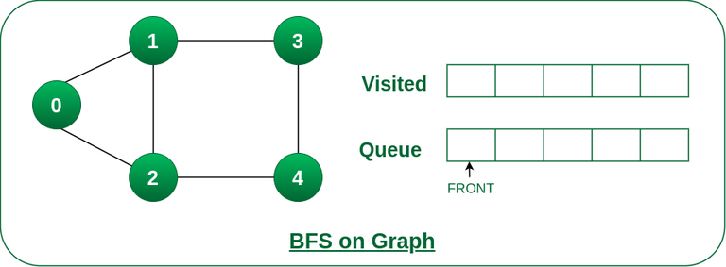
Queue and visited arrays are empty initially.
Step2: Push node 0 into queue and mark it visited.
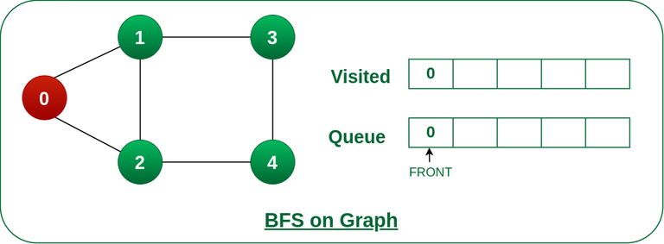
Push node 0 into queue and mark it visited.
Step 3: Remove node 0 from the front of queue and visit the unvisited neighbours and push them into queue.
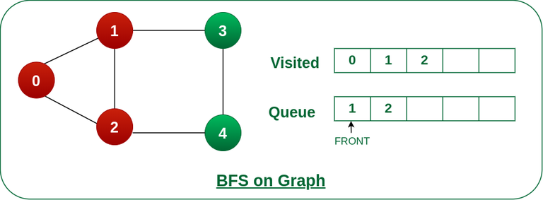
Remove node 0 from the front of queue and visited the unvisited neighbours and push into queue.
Step 4: Remove node 1 from the front of queue and visit the unvisited neighbours and push them into queue.
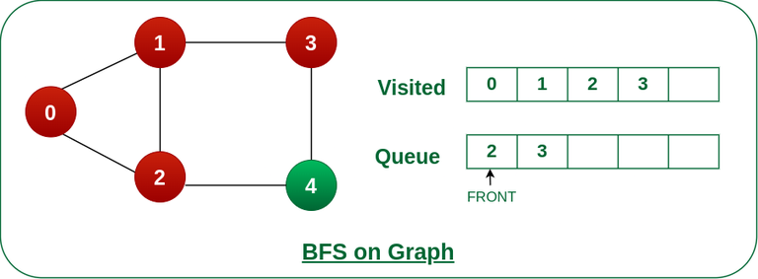
Remove node 1 from the front of queue and visited the unvisited neighbours and push
Step 5: Remove node 2 from the front of queue and visit the unvisited neighbours and push them into queue.
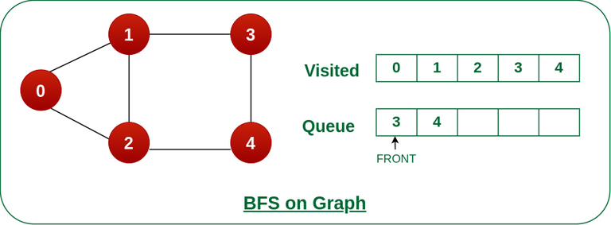
Remove node 2 from the front of queue and visit the unvisited neighbours and push them into queue.
Step 6: Remove node 3 from the front of queue and visit the unvisited neighbours and push them into queue.
As we can see that every neighbours of node 3 is visited, so move to the next node that are in the front of the queue.
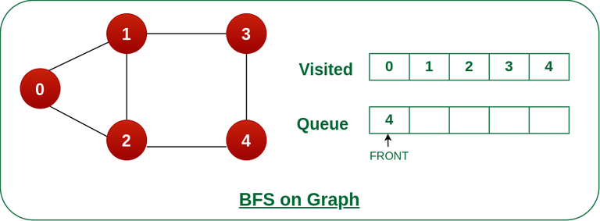
Remove node 3 from the front of queue and visit the unvisited neighbours and push them into queue.
Steps 7: Remove node 4 from the front of queue and visit the unvisited neighbours and push them into queue.
As we can see that every neighbours of node 4 are visited, so move to the next node that is in the front of the queue.
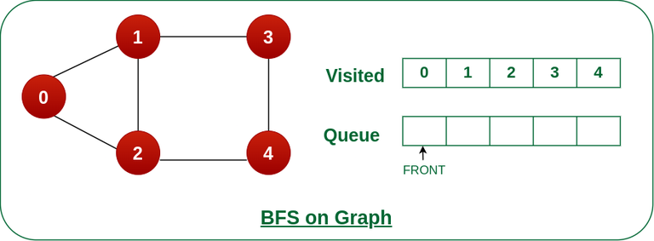
Remove node 4 from the front of queue and visit the unvisited neighbours and push them into queue.
Now, Queue becomes empty, So, terminate these process of iteration.

Implementation of BFS for Graph using Adjacency List:
- C++
- C
- Java
- C#
- Javascript
- Python3
#include <iostream>
#include <queue>
#include <vector>

using namespace std;

// Function to perform Breadth First Search on a graph
// represented using adjacency list
void bfs(vector<vector<int> >& adjList, int startNode,
vector<bool>& visited)
{
// Create a queue for BFS
queue<int> q;

// Mark the current node as visited and enqueue it
visited[startNode] = true;
q.push(startNode);

// Iterate over the queue
while (!q.empty()) {
// Dequeue a vertex from queue and print it
int currentNode = q.front();
q.pop();
cout << currentNode << " ";

// Get all adjacent vertices of the dequeued vertex
// currentNode If an adjacent has not been visited,
// then mark it visited and enqueue it
for (int neighbor : adjList[currentNode]) {
if (!visited[neighbor]) {
visited[neighbor] = true;
q.push(neighbor);
}
}
}
}

// Function to add an edge to the graph
void addEdge(vector<vector<int> >& adjList, int u, int v)
{
adjList[u].push_back(v);
}

int main()
{
// Number of vertices in the graph
int vertices = 5;

// Adjacency list representation of the graph
vector<vector<int> > adjList(vertices);

// Add edges to the graph
addEdge(adjList, 0, 1);
addEdge(adjList, 0, 2);
addEdge(adjList, 1, 3);
addEdge(adjList, 1, 4);
addEdge(adjList, 2, 4);

// Mark all the vertices as not visited
vector<bool> visited(vertices, false);

// Perform BFS traversal starting from vertex 0
cout << "Breadth First Traversal starting from vertex "
"0: ";
bfs(adjList, 0, visited);

return 0;
}
Output
Breadth First Traversal starting from vertex 0: 0 1 2 3 4
Time Complexity: O(V+E), where V is the number of nodes and E is the number of edges.
Auxiliary Space: O(V)

Complexity Analysis of Breadth-First Search (BFS) Algorithm:

Time Complexity of BFS Algorithm: O(V + E)
- BFS explores all the vertices and edges in the graph. In the worst case, it visits every vertex and edge once. Therefore, the time complexity of BFS is O(V + E), where V and E are the number of vertices and edges in the given graph.

Space Complexity of BFS Algorithm: O(V)
- BFS uses a queue to keep track of the vertices that need to be visited. In the worst case, the queue can contain all the vertices in the graph. Therefore, the space complexity of BFS is O(V), where V and E are the number of vertices and edges in the given graph.

Applications of BFS in Graphs:
BFS has various applications in graph theory and computer science, including:
- Shortest Path Finding: BFS can be used to find the shortest path between two nodes in an unweighted graph. By keeping track of the parent of each node during the traversal, the shortest path can be reconstructed.
- Cycle Detection: BFS can be used to detect cycles in a graph. If a node is visited twice during the traversal, it indicates the presence of a cycle.
- Connected Components: BFS can be used to identify connected components in a graph. Each connected component is a set of nodes that can be reached from each other.
- Topological Sorting: BFS can be used to perform topological sorting on a directed acyclic graph (DAG). Topological sorting arranges the nodes in a linear order such that for any edge (u, v), u appears before v in the order.
- Level Order Traversal of Binary Trees: BFS can be used to perform a level order traversal of a binary tree. This traversal visits all nodes at the same level before moving to the next level.
- Network Routing: BFS can be used to find the shortest path between two nodes in a network, making it useful for routing data packets in network protocols.

DFS (Depth First Search) algorithm
It is a recursive algorithm to search all the vertices of a tree data structure or a graph. The depth-first search (DFS) algorithm starts with the initial node of graph G and goes deeper until we find the goal node or the node with no children.
Because of the recursive nature, stack data structure can be used to implement the DFS algorithm. The process of implementing the DFS is similar to the BFS algorithm.
The step by step process to implement the DFS traversal is given as follows -
- First, create a stack with the total number of vertices in the graph.
- Now, choose any vertex as the starting point of traversal, and push that vertex into the stack.
- After that, push a non-visited vertex (adjacent to the vertex on the top of the stack) to the top of the stack.
- Now, repeat steps 3 and 4 until no vertices are left to visit from the vertex on the stack's top.
- If no vertex is left, go back and pop a vertex from the stack.
- Repeat steps 2, 3, and 4 until the stack is empty.

Applications of DFS algorithm
The applications of using the DFS algorithm are given as follows -
- DFS algorithm can be used to implement the topological sorting.
- It can be used to find the paths between two vertices.
- It can also be used to detect cycles in the graph.
- DFS algorithm is also used for one solution puzzles.
- DFS is used to determine if a graph is bipartite or not.

Algorithm
Step 1: SET STATUS = 1 (ready state) for each node in G
Step 2: Push the starting node A on the stack and set its STATUS = 2 (waiting state)
Step 3: Repeat Steps 4 and 5 until STACK is empty
Step 4: Pop the top node N. Process it and set its STATUS = 3 (processed state)
Step 5: Push on the stack all the neighbors of N that are in the ready state (whose STATUS = 1) and set their STATUS = 2 (waiting state)
[END OF LOOP]
Step 6: EXIT

Pseudocode
- DFS(G,v) ( v is the vertex where the search starts )
- Stack S := {}; ( start with an empty stack )
- for each vertex u, set visited[u] := false;
- push S, v;
- while (S is not empty) do
- u := pop S;
- if (not visited[u]) then
- visited[u] := true;
- for each unvisited neighbour w of uu
- push S, w;
- end if
- end while
- END DFS()

Example of DFS algorithm
Now, let's understand the working of the DFS algorithm by using an example. In the example given below, there is a directed graph having 7 vertices.
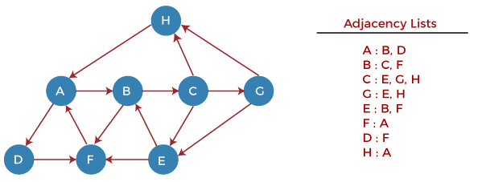
Now, let's start examining the graph starting from Node H.
Step 1 - First, push H onto the stack.
- STACK: H
Step 2 - POP the top element from the stack, i.e., H, and print it. Now, PUSH all the neighbors of H onto the stack that are in ready state.
- Print: H]STACK: A
Step 3 - POP the top element from the stack, i.e., A, and print it. Now, PUSH all the neighbors of A onto the stack that are in ready state.
- Print: A
- STACK: B, D
Step 4 - POP the top element from the stack, i.e., D, and print it. Now, PUSH all the neighbors of D onto the stack that are in ready state.
- Print: D
- STACK: B, F
Step 5 - POP the top element from the stack, i.e., F, and print it. Now, PUSH all the neighbors of F onto the stack that are in ready state.
- Print: F
- STACK: B
Step 6 - POP the top element from the stack, i.e., B, and print it. Now, PUSH all the neighbors of B onto the stack that are in ready state.
- Print: B
- STACK: C
Step 7 - POP the top element from the stack, i.e., C, and print it. Now, PUSH all the neighbors of C onto the stack that are in ready state.
- Print: C
- STACK: E, G
Step 8 - POP the top element from the stack, i.e., G and PUSH all the neighbors of G onto the stack that are in ready state.
- Print: G
- STACK: E
Step 9 - POP the top element from the stack, i.e., E and PUSH all the neighbors of E onto the stack that are in ready state.
- Print: E
- STACK:
Now, all the graph nodes have been traversed, and the stack is empty.

Complexity of Depth-first search algorithm
The time complexity of the DFS algorithm is O(V+E), where V is the number of vertices and E is the number of edges in the graph.
The space complexity of the DFS algorithm is O(V).
Depth First Traversal (or Search) for a graph is similar to Depth First Traversal (DFS) of a tree. The only catch here is, unlike trees, graphs may contain cycles, so a node might be visited twice. To avoid processing a node more than once, use a boolean visited array.
Example:
Input: n = 4, e = 6
0 -> 1, 0 -> 2, 1 -> 2, 2 -> 0, 2 -> 3, 3 -> 3
Output: DFS from vertex 1 : 1 2 0 3
Explanation:
DFS Diagram:

Input: n = 4, e = 6
2 -> 0, 0 -> 2, 1 -> 2, 0 -> 1, 3 -> 3, 1 -> 3
Output: DFS from vertex 2 : 2 0 1 3
Explanation:
DFS Diagram:


The recursive implementation of DFS is already discussed: previous post.
Solution:
- Approach: Depth-first search is an algorithm for traversing or searching tree or graph data structures. The algorithm starts at the root node (selecting some arbitrary node as the root node in the case of a graph) and explores as far as possible along each branch before backtracking. So the basic idea is to start from the root or any arbitrary node and mark the node and move to the adjacent unmarked node and continue this loop until there is no unmarked adjacent node. Then backtrack and check for other unmarked nodes and traverse them. Finally print the nodes in the path.
The only difference between iterative DFS and recursive DFS is that the recursive stack is replaced by a stack of nodes.
- Algorithm:
  - Created a stack of nodes and visited array.
  - Insert the root in the stack.
  - Run a loop till the stack is not empty.
  - Pop the element from the stack and print the element.
  - For every adjacent and unvisited node of current node, mark the node and insert it in the stack.
- Implementation of Iterative DFS: This is similar to BFS, the only difference is queue is replaced by stack.

C++
// An Iterative C++ program to do DFS traversal from
// a given source vertex. DFS(int s) traverses vertices
// reachable from s.
#include<bits/stdc++.h>
using namespace std;

// This class represents a directed graph using adjacency
// list representation
class Graph
{
int V; // No. of vertices
list<int> *adj; // adjacency lists
public:
Graph(int V); // Constructor
void addEdge(int v, int w); // to add an edge to graph
void DFS(int s); // prints all vertices in DFS manner
// from a given source.
};

Graph::Graph(int V)
{
this->V = V;
adj = new list<int>[V];
}

void Graph::addEdge(int v, int w)
{
adj[v].push_back(w); // Add w to v’s list.
}

// prints all not yet visited vertices reachable from s
void Graph::DFS(int s)
{
// Initially mark all vertices as not visited
vector<bool> visited(V, false);

// Create a stack for DFS
stack<int> stack;

// Push the current source node.
stack.push(s);

while (!stack.empty())
{
// Pop a vertex from stack and print it
int s = stack.top();
stack.pop();

// Stack may contain same vertex twice. So
// we need to print the popped item only
// if it is not visited.
if (!visited[s])
{
cout << s << " ";
visited[s] = true;
}

// Get all adjacent vertices of the popped vertex s
// If a adjacent has not been visited, then push it
// to the stack.
for (auto i = adj[s].begin(); i != adj[s].end(); ++i)
if (!visited[*i])
stack.push(*i);
}
}

// Driver program to test methods of graph class
int main()
{
Graph g(5); // Total 5 vertices in graph
g.addEdge(1, 0);
g.addEdge(0, 2);
g.addEdge(2, 1);
g.addEdge(0, 3);
g.addEdge(1, 4);

cout << "Following is Depth First Traversal\n";
g.DFS(0);

return 0;
}

Spanning tree
In this article, we will discuss the spanning tree and the minimum spanning tree. But before moving directly towards the spanning tree, let's first see a brief description of the graph and its types.

Graph
A graph can be defined as a group of vertices and edges to connect these vertices. The types of graphs are given as follows -
- Undirected graph: An undirected graph is a graph in which all the edges do not point to any particular direction, i.e., they are not unidirectional; they are bidirectional. It can also be defined as a graph with a set of V vertices and a set of E edges, each edge connecting two different vertices.
- Connected graph: A connected graph is a graph in which a path always exists from a vertex to any other vertex. A graph is connected if we can reach any vertex from any other vertex by following edges in either direction.
- Directed graph: Directed graphs are also known as digraphs. A graph is a directed graph (or digraph) if all the edges present between any vertices or nodes of the graph are directed or have a defined direction.
Now, let's move towards the topic spanning tree.

What is a spanning tree?
A spanning tree can be defined as the subgraph of an undirected connected graph. It includes all the vertices along with the least possible number of edges. If any vertex is missed, it is not a spanning tree. A spanning tree is a subset of the graph that does not have cycles, and it also cannot be disconnected.
A spanning tree consists of (n-1) edges, where 'n' is the number of vertices (or nodes). Edges of the spanning tree may or may not have weights assigned to them. All the possible spanning trees created from the given graph G would have the same number of vertices, but the number of edges in the spanning tree would be equal to the number of vertices in the given graph minus 1.
A complete undirected graph can have n^{n-2} number of spanning trees where n is the number of vertices in the graph. Suppose, if n = 5, the number of maximum possible spanning trees would be 5⁵⁻² = 125.

Applications of the spanning tree
Basically, a spanning tree is used to find a minimum path to connect all nodes of the graph. Some of the common applications of the spanning tree are listed as follows -
- Cluster Analysis
- Civil network planning
- Computer network routing protocol
Now, let's understand the spanning tree with the help of an example.

Example of Spanning tree
Suppose the graph be -
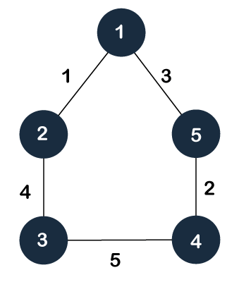
As discussed above, a spanning tree contains the same number of vertices as the graph, the number of vertices in the above graph is 5; therefore, the spanning tree will contain 5 vertices. The edges in the spanning tree will be equal to the number of vertices in the graph minus 1. So, there will be 4 edges in the spanning tree.
Some of the possible spanning trees that will be created from the above graph are given as follows -
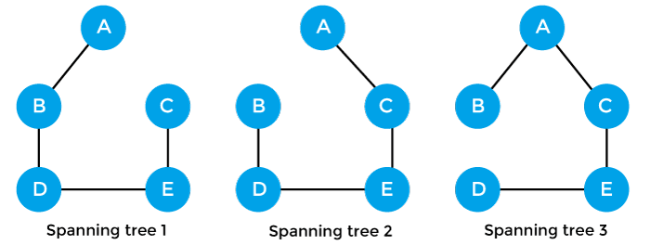

Properties of spanning-tree
Some of the properties of the spanning tree are given as follows -
- There can be more than one spanning tree of a connected graph G.
- A spanning tree does not have any cycles or loop.
- A spanning tree is minimally connected, so removing one edge from the tree will make the graph disconnected.
- A spanning tree is maximally acyclic, so adding one edge to the tree will create a loop.
- There can be a maximum n^{n-2} number of spanning trees that can be created from a complete graph.
- A spanning tree has n-1 edges, where 'n' is the number of nodes.
- If the graph is a complete graph, then the spanning tree can be constructed by removing maximum (e-n+1) edges, where 'e' is the number of edges and 'n' is the number of vertices.
So, a spanning tree is a subset of connected graph G, and there is no spanning tree of a disconnected graph.

Minimum Spanning tree
A minimum spanning tree can be defined as the spanning tree in which the sum of the weights of the edge is minimum. The weight of the spanning tree is the sum of the weights given to the edges of the spanning tree. In the real world, this weight can be considered as the distance, traffic load, congestion, or any random value.

Example of minimum spanning tree
Let's understand the minimum spanning tree with the help of an example.
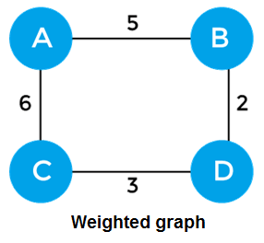
The sum of the edges of the above graph is 16. Now, some of the possible spanning trees created from the above graph are -
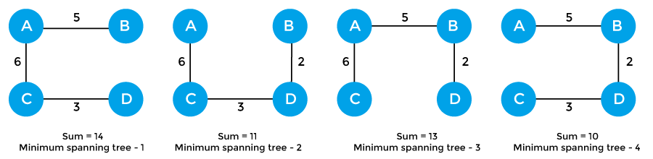
So, the minimum spanning tree that is selected from the above spanning trees for the given weighted graph is -
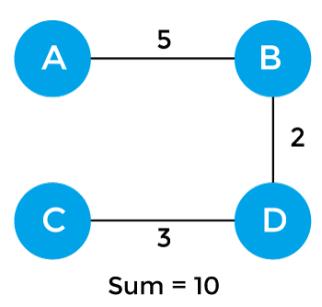

Applications of minimum spanning tree
The applications of the minimum spanning tree are given as follows -
- Minimum spanning tree can be used to design water-supply networks, telecommunication networks, and electrical grids.
- It can be used to find paths in the map.

Algorithms for Minimum spanning tree
A minimum spanning tree can be found from a weighted graph by using the algorithms given below -
- Prim's Algorithm
- Kruskal's Algorithm
Prim's algorithm - It is a greedy algorithm that starts with an empty spanning tree. It is used to find the minimum spanning tree from the graph. This algorithm finds the subset of edges that includes every vertex of the graph such that the sum of the weights of the edges can be minimized.
To learn more about the prim's algorithm, you can click the below link - https://www.javatpoint.com/prim-algorithm
Kruskal's algorithm - This algorithm is also used to find the minimum spanning tree for a connected weighted graph. Kruskal's algorithm also follows greedy approach, which finds an optimum solution at every stage instead of focusing on a global optimum.

